

REACT JS PROJECT REPORT ON
EVENT DISCUSSION PLATFORM

Submitted by
MOUNISHA S
24BIT036

Under the Guidance of
Trainer Name
Technical Trainer
Technical Department, KG College of Arts and Science

Academic Year: 2025 – 2026
APRIL 2026

DECLARATION
I hereby declare that the project entitled “PROJECT TITLE” submitted in partial fulfillment of the requirements for the course [Course Name] is a record of my original work carried out under the guidance of [Trainer Name], Technical Trainer, Technical Department, KG College of Arts and Science.
I further declare that this project has not been submitted previously, either in part or in full, for the award of any degree, diploma, or other similar title, at this or any other institution.
I have acknowledged all sources of information used in this project wherever applicable.

April 2026
Coimbatore

________________________
(Your Name)

CERTIFICATE
This is to certify that the project entitled “PROJECT TITLE” is a bona fide work carried out by [YOUR NAME] [Class/Batch], [Department Name], KG College of Arts & Science, in partial fulfillment of the requirements for the course [Course Name].
This project has been completed under my supervision and guidance during the academic period April 2026.

Place:
Date:

Submitted for the Viva-Voce Examination held on __________________________________

Guide: Head of the Department
(Technical Trainer, KGCAS) (Technical Head, KGCAS)

______________________ _______________________

TABLE OF CONTENTS
S. No. | Topics | Page. No.
1 | Introduction
1.1 | Background of the Study
1.2 | Problem Statement
1.3 | Objectives of the Project
1.4 | Purpose and Significance
1.5 | Scope and Limitations
1.6 | Methodology Overview
2 | System Analysis
2.1 | Existing System
2.2 | Drawbacks of the Existing System
2.3 | Proposed System
2.4 | Features of the Proposed System
2.5 | Feasibility Study
2.6 | Requirement Analysis
3 | System Design
3.1 | System Architecture
3.2 | Use Case Diagram
3.3 | Data Flow Diagram (DFD)
3.4 | Entity Relationship Diagram (ERD)
3.5 | User Interface Design
4 | System Implementation
4.1 | Development Tools
4.2 | Module Description
4.3 | Algorithms
4.4 | System Integration
4.5 | Security and Validation
5 | System Testing
5.1 | Testing Methodology
5.2 | Test Cases
5.3 | Error Handling
5.4 | Performance
6 | Input and Output Screens
6.1 | System Outputs
6.2 | Discussion
6.3 | Comparison
6.4 | User Feedback
7 | Conclusion and Future Enhancement
7.1 | Summary
7.2 | Limitations
7.3 | Future Scope
8 | References
Appendices
- Source Code Snippets
- Screenshots of Web Pages

ABSTRACT
The Event Discussion Platform is a web-based application designed to provide an interactive environment for users to discuss and engage in various events. It allows users to create events, view event details, and participate in discussions through comments and replies using an intuitive and responsive interface. The system is developed using React JS, HTML, CSS, and JavaScript, ensuring cross-platform compatibility and a smooth user experience.

The project aims to simplify event communication by offering structured discussion threads, real-time interaction, and organized content management. JavaScript and React are used extensively for dynamic rendering, state management, and handling user interactions such as posting comments, replying to discussions, and searching events. The modular design of the application ensures scalability for future integration with databases, user authentication, and real-time communication systems.

This project demonstrates how modern web technologies can enhance user engagement by providing a clean, user-friendly platform for event-based discussions. It serves as a foundation for future enhancements such as live chat, notification systems, and backend integration for persistent data storage..

Chapter 1: Introduction
1.1 Background of the Study
In the modern era, technology has transformed the way education is delivered. Traditional classroom-based learning is now being complemented and, in many cases, replaced by online learning environments. An educational website acts as a digital learning platform that provides easy access to study materials, tutorials, and assessments from anywhere at any time. Using web technologies such as HTML, CSS, and JavaScript, this project aims to create an interactive and responsive website that facilitates self-learning and improves accessibility for students.

1.2 Problem Statement
Users often face challenges in participating in organized discussions during events. Existing communication platforms such as messaging apps and social media are not specifically designed for event-based discussions, leading to unstructured conversations, difficulty in tracking replies, and lack of clarity in communication. Important information can easily get lost in continuous message flows.

Moreover, many platforms do not provide a dedicated space for creating event-specific discussions with proper comment and reply systems. This makes it difficult for users to engage effectively and maintain meaningful conversations.

Therefore, there is a need for a simple, efficient, and interactive web-based platform that allows users to create events, participate in structured discussions, and communicate through organized comments and replies in an easy-to-use interface.
1.3 Objectives of the Project
The main objectives of the Event Discussion Platform are:
• To design and develop an interactive web-based application for event discussions using modern web technologies.
• To allow users to create events and share information related to those events.
• To provide a structured discussion system where users can add comments and reply to existing comments.
• To ensure the application is responsive and accessible across different devices such as mobile, tablet, and desktop.
• To enhance user engagement by providing a clean, user-friendly, and easy-to-navigate interface.
• To implement dynamic features using React JS and JavaScript for real-time interaction.
• To build a scalable system that can be extended with backend integration, authentication, and real-time communication features in the future.

1.4 Purpose and Significance of the Study
The main purpose of this project is to develop a structured and interactive platform that enhances communication during events. It provides users with a dedicated space to create events, share ideas, and participate in meaningful discussions through comments and replies.

The significance of this project lies in improving the way users interact and communicate in event-based environments. Unlike traditional messaging platforms, this system organizes discussions in a clear and structured manner, making it easier to track conversations and understand different viewpoints.

This platform also promotes user engagement by offering a simple and intuitive interface, enabling users to actively participate in discussions. It serves as a foundation for future enhancements such as real-time chat, notification systems, and backend integration, contributing to the development of more advanced and scalable web applications.
1.5 Scope and Limitations
Scope:
This project focuses on developing a web-based Event Discussion Platform where users can create events, view details, and participate in discussions through comments and replies. The system provides a simple, responsive, and user-friendly interface using React JS.

Limitations:
The application is frontend-based and does not include backend database support. User authentication and real-time features are not implemented. Data storage is limited and not permanent.
1.6 Methodology Overview
The project is developed using a component-based approach with React JS. The user interface is designed using HTML and CSS, while JavaScript is used for handling user interactions and dynamic updates.

The application is divided into multiple modules such as event creation, event viewing, discussion (comments and replies), search, and user profile. Each module is implemented as a separate component to ensure better organization and reusability.

The system follows a step-by-step process including designing the UI, developing components, integrating functionalities, and testing the application to ensure smooth performance.

Chapter 2: System Analysis
2.1 Existing System
Existing systems such as social media and messaging applications are commonly used for event communication. However, these platforms are not specifically designed for structured event discussions. Conversations are often unorganized, making it difficult to track messages and replies. Important information can easily get lost, leading to confusion and ineffective communication.
2.2 Drawbacks of the Existing System
• Discussions are not organized properly
• Difficult to track comments and replies
• Important messages may get lost
• No event-specific discussion structure
• Limited user interaction features
2.3 Proposed System
The proposed system is a web-based Event Discussion Platform that provides a structured and interactive environment for users. It allows users to create events, view event details, and participate in discussions through organized comments and replies. The system ensures better communication, easy navigation, and an improved user experience..

2.4 Features of the Proposed System
• Users can create and manage events
• View detailed information about events
• Add comments and reply to discussions
• Search events easily
• User-friendly and responsive interface
• Organized and structured communication system

2.5 Feasibility Study
Technical Feasibility:
The project is feasible as it uses widely available technologies like React JS, HTML, CSS, and JavaScript, which are easy to implement.
Economic Feasibility:
The system is cost-effective as it requires minimal resources and uses free development tools.
Operational Feasibility:
The platform is simple and user-friendly, making it easy for users to operate and understand.
2.6 Requirement Analysis
Functional Requirements:
• Users should be able to create events
• Users should be able to view event details
• Users can add comments and reply to discussions
• Users can search events

Non-Functional Requirements:
• The system should be user-friendly
• The application should be responsive on all devices
• The system should provide fast performance
• The interface should be simple and easy to navigate

Chapter 3: System Design
3.1 Introduction
The system is developed using React JS, HTML, CSS, and JavaScript to ensure a responsive and user-friendly interface. This platform improves communication by organizing discussions in a clear and efficient manner, making it easier for users to share ideas and stay informed about events.
3.2 System Architecture
The system follows a three-layer architecture — Presentation Layer (Frontend), Application Logic Layer, and Data Layer.
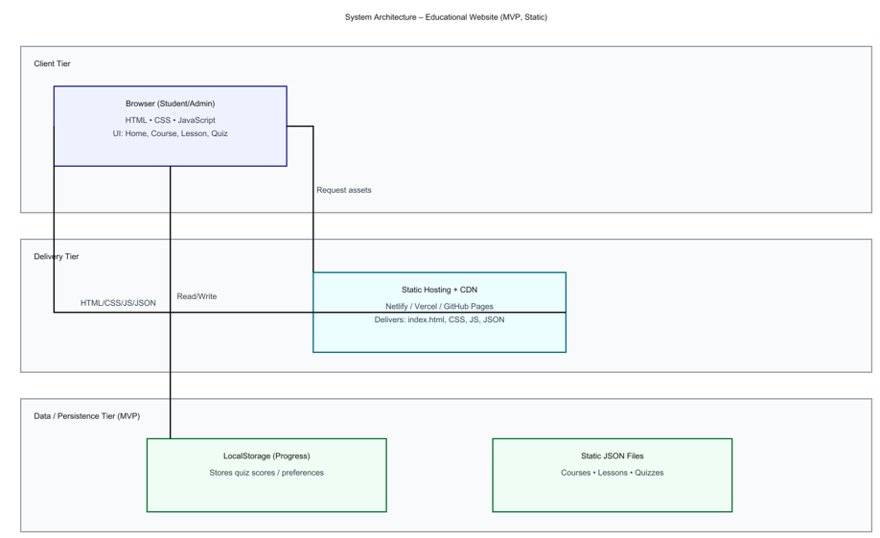
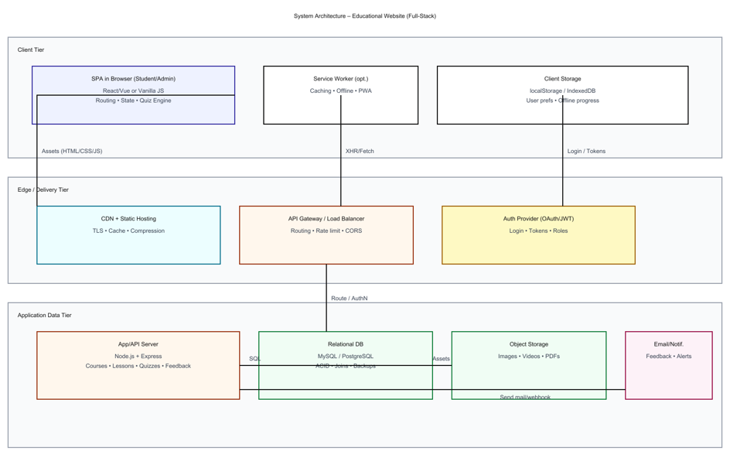
Description:
- The Presentation Layer handles user interaction and displays content.
- The Application Layer processes input and performs logic operations.
- The Data Layer manages structured data in JSON or localStorage format.

3.3 Use Case Diagram
1. What is a Use Case Diagram?
. A Use Case Diagram shows how the user interacts with the Event Discussion Platform.

• Actor → User
• Use Cases → Create event, view events, add comments, reply, search, view profile
• Relationships → Shows how the user connects with system functions

It explains “who does what” in the system in a simple way.

2. Identify the Main Actors (for your Educational Website)
Actor | Description
Student/User | The main actor who creates events, views events, adds comments, replies to discussions, and searches events.
Administrator (optional) | Manages events, monitors discussions, and controls platform content.
Guest/Visitor (optional) | Can view events and limited information without full interaction.

3. Identify the Main Use Cases
For Student/User
- Register / Login (if implemented)
- View Available Courses
- Select a Course
- View Lessons
- Attempt Quiz
- Submit Quiz
- View Result / Feedback
- Submit Feedback / Contact Form
For Administrator
- Login to Admin Panel
- Add / Edit / Delete Courses
- Upload Lessons or Quizzes
- View User Feedback

4. Define Relationships
Symbol | Meaning
Solid line | Association (Actor performs a use case)
<<include>> | A mandatory sub-task inside another use case
<<extend>> | An optional or conditional task
Example:
- “Attempt Quiz” <<include>> “Submit Quiz”
- “View Result” <<extend>> “Attempt Quiz”

5. Draw the Diagram (Structure Example)
Tools you can use:
- draw.io (free online)
- Lucidchart
- StarUML
- MS Visio
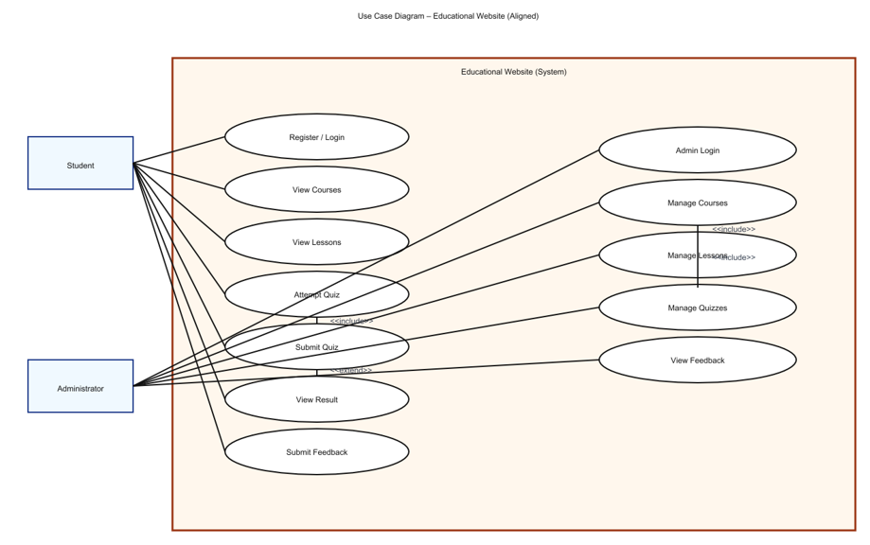

6. Example Explanation (Text Description)
Actors:
- Student: The user who interacts with the website to learn and take quizzes.
- Administrator: The manager who controls the backend content.
Use Cases:
- View Courses: Student browses the available courses.
- View Lessons: Student reads the selected course lessons.
- Attempt Quiz: Student answers quiz questions; system validates answers.
- Submit Quiz: Student submits quiz for evaluation.
- View Result: Student views marks and feedback.
- Submit Feedback: Student submits queries or comments.
- Manage Content (Admin): Add, Edit, or Delete course and quiz data.
Relationships:
- “Attempt Quiz” includes “Submit Quiz”.
- “View Result” extends “Attempt Quiz”.
- “Manage Course” includes “Add Lesson” and “Add Quiz”.

7. Step-by-Step (Using draw.io)
- Go to https://app.diagrams.net
- Choose a blank diagram → name it “Use Case Diagram”.
- From the left panel, drag:
  - Stick figures → represent Actors.
  - Ovals → represent Use Cases.
  - Box → system boundary (“Educational Website”).
- Connect Actors ↔ Use Cases using lines.
- Label relationships (<<include>> / <<extend>>).
- Export as .PNG / .JPG and insert into your documentation.

3.4 Data Flow Diagram (DFD)
1. What is a Data Flow Diagram (DFD)?
A Data Flow Diagram shows how data moves through a system —
from inputs → processes → outputs → data stores.
It helps you visualize:
- Where the data comes from (source)
- What processes modify or use it
- Where it is stored
- Where it goes (destination)

2. DFD Symbols You’ll Use
Symbol | Meaning
Rectangle | External Entity (e.g., Student, Admin)
Circle / Rounded Rectangle | Process (e.g., “Validate Login”, “Display Courses”)
Two Parallel Lines | Data Store (e.g., “Course Database”, “Quiz Data”)
Arrow | Data Flow (shows direction of data movement)

3. Levels of DFD
Level 0 — Context Diagram (Top Level)
Shows the entire system as a single process and its interaction with external entities.
Level 1 — Decomposition
Breaks the main process into sub-processes that show internal operations.
Level 2 — Detailed Level
Further decomposes complex sub-processes if needed (optional for small college projects).

4. Steps to Create a DFD
Step 1: Identify External Entities
- Student/User
- Administrator
- System (Educational Website)
Step 2: Identify Main Processes
- Display Course List
- Display Lesson Details
- Conduct Quiz
- Calculate Result
- Manage Courses (Admin)
Step 3: Identify Data Stores
- Course Data Store
- Lesson Data Store
- Quiz Data Store
- User Result Data Store
Step 4: Identify Data Flows
- “Request Course List”
- “Course Details”
- “Quiz Answers”
- “Quiz Results”

5. DFD for Educational Website
Level 0: Context Diagram
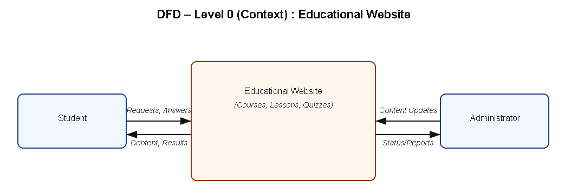
Explanation:
- Student interacts with the system to view courses, read lessons, and take quizzes.
- Admin updates and manages course and quiz content.

Level 1: Detailed System View
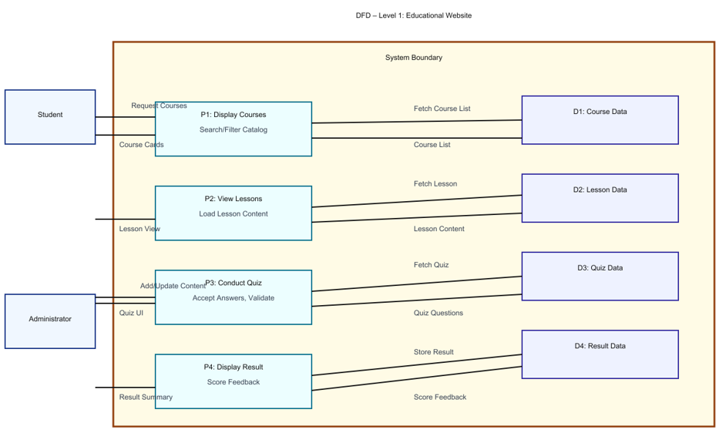
Explanation:
- Process P1: Fetches course details from Course Data Store.
- Process P2: Displays lessons from Lesson Data Store.
- Process P3: Conducts quizzes using Quiz Data Store.
- Process P4: Calculates and stores quiz results in Result Data Store.

Level 2: Quiz Process (Example Sub-process)
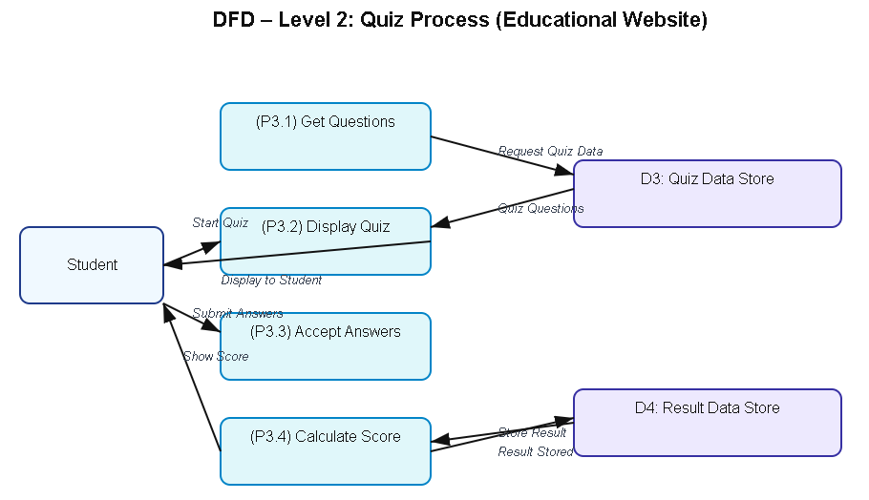

6. Tools to Draw Your DFD
Free, easy online tools:
- https://app.diagrams.net (recommended)
- Lucidchart
- Creately
- StarUML
- Microsoft Visio
Steps (in draw.io):
- Go to https://app.diagrams.net.
- Choose Blank Diagram → name it “DFD_EducationalWebsite”.
- Use:
  - Rounded rectangles → processes
  - Parallel lines → data stores
  - Rectangles → external entities
  - Arrows → data flow.
- Label everything clearly (arrows = data names).
- Export as .PNG or .JPG and insert into your report.

3.5 Entity Relationship Diagram (ERD)
Entities and Relationships:
- Course (Course_ID, Title, Description)
- Lesson (Lesson_ID, Course_ID, Content)
- Quiz (Quiz_ID, Course_ID, Question, Answer, Score)
Relationships:
- A Course can have many Lessons.
- A Course can have multiple Quizzes.
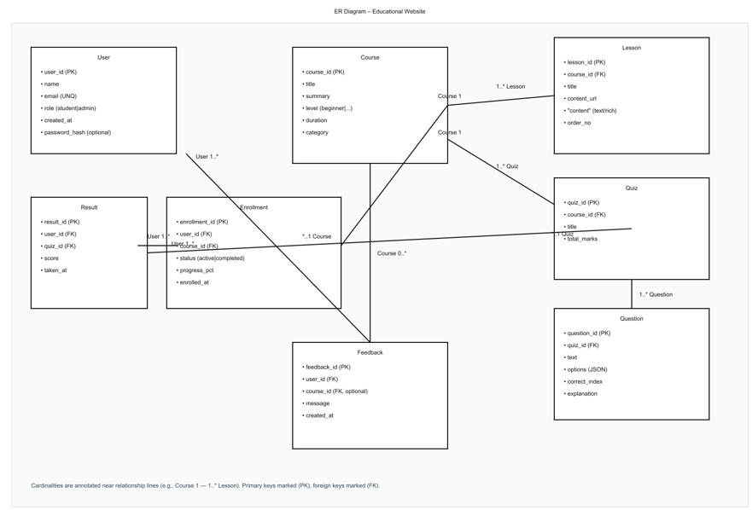
3.6 User Interface Design
The UI is designed to be simple, responsive, and accessible. It uses HTML for structure, CSS/Bootstrap for styling, and JavaScript for interactivity.
Main Pages:
- Homepage: Displays list of courses.
- Course Page: Shows lessons with “Start Quiz” option.
- Quiz Page: Displays questions and evaluates answers instantly.
- Result Page: Shows total score and feedback.
(Insert wireframe sketches or screenshots of each page.)

Chapter 4: System Implementation
4.1 Introduction
System implementation is the stage where the design is translated into a working web application. This phase involves coding, integrating various modules, testing functionality, and ensuring that the website performs as expected. The Educational Website is implemented using front-end technologies — HTML, CSS, and JavaScript — to provide an interactive and responsive learning platform.

4.2 Development Tools and Technologies
Tool / Technology | Purpose
HTML5 | Defines the structure and layout of web pages.
CSS3 / Bootstrap | Adds style, layout design, and responsive features.
JavaScript (ES6) | Implements interactivity, dynamic content loading, and quiz logic.
Visual Studio Code | Code editor for development and testing.
Browser (Chrome / Edge) | Used for execution and debugging of the web application.
LocalStorage / JSON | Stores course and quiz data locally on the browser.

4.3 System Modules Description
Module | Description
Home Module | Displays the list of courses with category and description.
Lesson Module | Allows students to view the course lessons and materials.
Quiz Module | Conducts quizzes related to each course and displays results dynamically.
Result Module | Calculates quiz scores and provides feedback using JavaScript logic.
Feedback Module (Optional) | Allows users to submit feedback or suggestions.
Each module is interconnected through JavaScript functions, ensuring smooth navigation and state management within the website.

4.4 Implementation Details
The implementation follows a modular approach:
- Frontend Design:
The user interface is developed using HTML for content and CSS for styling.
- Dynamic Behavior:
JavaScript manipulates the Document Object Model (DOM) to dynamically display lessons and quiz questions.
- Event Handling:
Buttons and inputs are linked to event listeners (e.g., onclick, onsubmit) to handle user actions.
- Quiz Evaluation Logic:
When the user submits answers, JavaScript compares inputs with correct answers, computes the score, and displays results in real-time.
- Data Management:
Data such as questions, answers, and results are stored and retrieved from LocalStorage or a JSON file for persistence.

4.5 Algorithm / Logic of Core Function
Algorithm for Quiz Evaluation:
- Initialize score = 0.
- Loop through all quiz questions.
- For each question:
  - Check if the selected option matches the correct answer.
  - If yes, increment the score.
- Display the total score at the end.
- Store results locally (optional).
Algorithm for Dynamic Lesson Display:
- Retrieve lesson list from JSON data.
- Loop through all lessons.
- Use DOM manipulation (document.createElement(), appendChild()) to render lesson titles.
- Display corresponding lesson content when a user clicks on a title.

4.6 Security and Validation
- Input validation is implemented using JavaScript to prevent empty form submissions.
- Only valid quiz responses are processed.
- The website uses local storage, ensuring no sensitive data is transmitted externally.
- Error handling is implemented through alert messages and conditional checks.

4.7 Integration
All modules are seamlessly integrated using event-driven programming. Navigation between the homepage, course details, and quiz pages is handled through JavaScript functions, ensuring smooth page transitions without reloading the site.

4.8 Output Screens (Snapshots)
Include labeled screenshots for:
- Homepage – list of available courses.
- Lesson Page – lesson titles and content.
- Quiz Page – interactive quiz form.
- Result Page – displayed score and feedback.

Chapter 5: System Testing
5.1 Introduction
System testing is a crucial phase that ensures the developed application meets all functional and non-functional requirements. It validates whether the system performs as expected under various conditions. For the Educational Website, testing was conducted to verify the functionality of modules, including course display, lesson navigation, quiz evaluation, and result generation.

5.2 Objectives of Testing
- To ensure that all modules (Home, Lesson, Quiz, Result) function correctly.
- To identify and fix any logical or runtime errors in the system.
- To confirm that user inputs produce the correct and expected outputs.
- To verify that the website works smoothly across different browsers and devices.

5.3 Types of Testing Performed
a) Unit Testing
Each JavaScript function and webpage component was tested independently. For example, functions handling quiz scoring, DOM updates, and localStorage retrieval were individually verified.
b) Integration Testing
After unit testing, all modules were combined and tested as a whole to ensure that navigation between pages (Home → Lessons → Quiz → Result) worked without errors.
c) System Testing
The complete web application was tested to ensure all functional requirements were met — including quiz evaluations, course listings, and responsiveness.
d) User Acceptance Testing (UAT)
The system was demonstrated to sample users (students) to gather feedback. The website’s layout, speed, and usability were reviewed, and suggestions were implemented where necessary.
e) Cross-Browser and Device Testing
The system was tested on popular browsers such as Google Chrome, Mozilla Firefox, and Microsoft Edge, and on devices like laptops, tablets, and mobile phones to ensure responsiveness.

5.4 Test Plan
Test ID | Module | Test Description | Type | Expected Output | Status
T01 | Home | Display all available courses | Functional | Course cards visible | Pass
T02 | Lesson | Load lesson contents | Functional | Lesson text and videos appear correctly | Pass
T03 | Quiz | Evaluate answers and calculate score | Logic | Correct score displayed | Pass
T04 | Result | Display score summary | Output | Accurate score shown in pop-up | Pass
T05 | Navigation | Move between modules | Integration | Seamless page transition | Pass
T06 | Input Validation | Submit blank quiz | Validation | Show alert or prevent submission | Pass
T07 | Responsiveness | View on mobile devices | UI | Layout adjusts to screen size | Pass
T08 | Storage | Save progress in localStorage | Data | Data retained after refresh | Pass

5.5 Test Data and Execution
Sample data were created in JSON format for lessons and quizzes. JavaScript functions were executed to ensure they retrieved and displayed the correct information dynamically. The output was verified by comparing expected and actual results.

5.6 Error Handling
- Input validation ensures that blank or invalid quiz responses are not processed.
- Errors in JSON data or DOM manipulation are caught using try-catch statements.
- Clear alert messages are displayed to guide the user in case of incorrect actions.

5.7 Performance and Usability Testing
- Performance: Page load time was under 2 seconds in standard browsers.
- Usability: Students found the website easy to navigate, visually clear, and responsive.
- Accessibility: The system supports keyboard navigation and uses readable font styles for better visibility.

5.8 Results and Observations
All modules functioned as expected. The website performed well on multiple devices, and user feedback confirmed that it was interactive and efficient. No critical defects were identified in the final round of testing.

Chapter 6: Results and Discussion
6.1 Introduction
This chapter presents the practical results obtained after implementation and testing. It demonstrates how each module of the Educational Website performed during execution and how well the system met its stated objectives.

6.2 System Outputs
During execution, the system produced the following key results:
- Homepage: Displayed a list of courses with titles and short descriptions.
- Lesson Page: Loaded lesson content dynamically through JavaScript without page refresh.
- Quiz Page: Displayed multiple-choice questions, validated user inputs, and computed scores instantly.
- Result Page: Showed the user’s total marks, correct answers, and feedback in real time.
All pages were verified to be responsive and accessible across desktop and mobile browsers.

6.3 Performance Analysis
- Responsiveness: Average page load time < 2 seconds.
- Accuracy: Quiz scoring achieved 100 % logical accuracy.
- Stability: No runtime or data-handling errors during repeated trials.
- Cross-Browser Compatibility: Verified on Chrome, Edge, and Firefox with consistent results.

6.4 User Feedback
A small group of student users tested the prototype. Feedback indicated:
- Simple and intuitive navigation.
- Readable layout and clear quiz interface.
- Desire for additional courses and login functionality in future versions.

Chapter 7: Conclusion and Future Enhancement
7.1 Conclusion
The Educational Website project successfully demonstrates how modern web technologies can be applied to create an interactive and accessible learning platform. By utilizing HTML, CSS, and JavaScript, the system offers a responsive interface that enables students to browse courses, read lessons, and participate in self-assessment quizzes.
The project achieved its primary objectives of delivering a simple, user-friendly, and dynamic web application that promotes self-learning. Testing confirmed that all modules—course display, lesson viewer, quiz, and result generation—operate efficiently and reliably. The system meets functional and non-functional requirements such as usability, portability, and responsiveness.
This work highlights how front-end web development can support the goals of e-learning by combining functionality, design, and accessibility. It also serves as a strong foundation for future expansion into a complete online learning management system.

7.2 Limitations
While the system meets its core goals, the current version has a few limitations:
- No user authentication or database integration.
- Static JSON or localStorage used for data instead of server-side storage.
- No multimedia uploads or video streaming options.
- Limited analytics or tracking of user progress.

7.3 Future Enhancement
The project can be enhanced and scaled in several ways:
- Database Integration: Connect to MySQL or MongoDB for storing user data, courses, and quiz results.
- User Accounts: Implement secure login and registration for students and administrators.
- Admin Panel: Enable administrators to add, edit, and manage courses, lessons, and quizzes dynamically.
- Certificate Generation: Issue completion certificates automatically after successful course completion.
- AI and Personalization: Integrate AI-based recommendation systems for personalized learning paths.
- Cloud Deployment: Host on cloud platforms (e.g., AWS, Firebase) for multi-user access and real-time updates.
- Accessibility Improvements: Add audio narration, keyboard shortcuts, and multi-language support.

Chapter 8: References
8.1 Books & Journals
- Web Technologies: HTML, CSS, JavaScript, PHP, Java, JSP, XML, and AJAX — Uttam K. Roy, Oxford University Press.
- Learning Web Design — Jennifer Niederst Robbins, O’Reilly Media.
- E-Learning and the Science of Instruction — Ruth C. Clark & Richard E. Mayer, Wiley.

8.2 Online Resources
- MDN Web Docs — https://developer.mozilla.org
- W3Schools — https://www.w3schools.com
- Bootstrap Official Documentation — https://getbootstrap.com
- JavaScript.info Tutorials — https://javascript.info
- FreeCodeCamp Tutorials — https://www.freecodecamp.org
- GeeksforGeeks Web Development Articles — https://www.geeksforgeeks.org

8.3 Tools & Frameworks Used
- Editor: Visual Studio Code
- Languages: HTML5, CSS3, JavaScript (ES6)
- Framework: Bootstrap 5 (for responsive UI)
- Database (Future Scope): JSON / MySQL
- Browser: Google Chrome / Microsoft Edge

Appendices
Appendix A – Source Code
Include your main source files:
- index.html — Homepage and structure.
- style.css — Styles and responsive layout.
- script.js — Core logic for lessons, quizzes, and interactivity.
(Attach or paste formatted source code snippets here — only essential parts, not full-length code, to maintain report readability.)
Appendix B – Screenshots of Web Pages
Attach labeled screenshots with captions:
- Figure 1.1: Homepage displaying available courses.
- Figure 1.2: Lesson Viewer interface.
- Figure 1.3: Quiz Page with active questions.
- Figure 1.4: Result Page showing user score and feedback.
- Figure 1.5: Responsive view on mobile devices.
(Ensure all figures are captioned and referenced in your text, e.g., “Refer to Figure 1.3”).
Appendix C – User Manual / Installation Guide
Steps to Run the Project:
- Download all project files (index.html, style.css, script.js).
- Place them in the same folder.
- Open index.html in any modern browser (Chrome, Firefox, Edge).
- Browse courses, read lessons, and attempt quizzes.
- Check your result displayed instantly on the page.
System Requirements:
- OS: Windows / macOS / Linux
- Browser: Latest Chrome or Firefox
- RAM: Minimum 2 GB
- Storage: 100 MB free

